Test Hose
Description and application
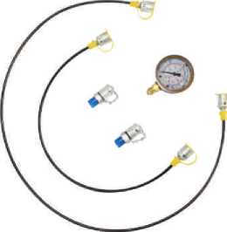
Test pressure hose is applied in micro hydraulic system and testing pressure in hydraulic system.It's specification includesjight weight.wear resistance,strong in pact res istamce, good flexibility.friendly use.and so on.
Fluid service： mineral oil, water-glycol, alcohol, gasoline, water-oil emulsions, gas, etc。
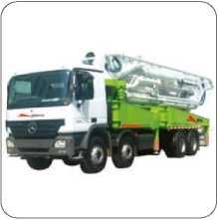
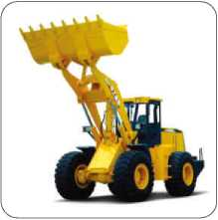
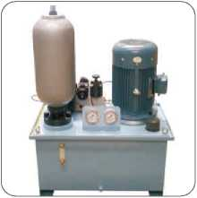
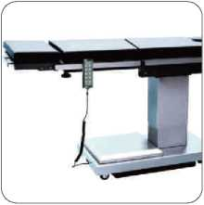
(Technical information )
 |  | DN2-400 | DN2-630 | DN3-630 | DN4-500
inside diameter | mm | 2 | 2 | 3 | 4
outer diameter | mm | 5 | 5 | 6 | 8
Max. quiescent pressure | Bar | 400 | 630 | 630 | 500
Min. burst pressure | Bar | 1200 | 1890 | 1890 | 1500
Min. bending radius | mm | 20 | 20 | 25 | 35
weight | g | 20 | 20 | 27 | 47
temperature range | °C | ■40 〜+100 | -40 〜+100 | -40 〜+100 | ■40 〜+100
core material |  | PA
reinforcement material |  | Fiber or Kevlar
cover material |  | PA or PU

How to order
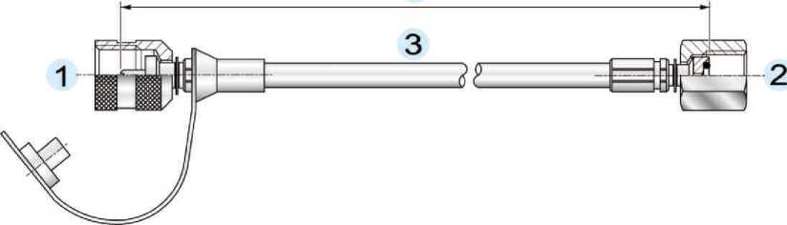

HF 1 -2-3-P*-5
HF Abbreviation of micro high pressure flexiable hose assembly
1 Fitting model of one end
2 Fitting model of the other end
3 Hose type (2 = DN2, 3=DN3, 4=DN4)
P* Pressure class (P40=400bar, P60=630bar)
5 Hose length:mm
1 For example: One end with quick fitting of connecting thread is M16X 2. The other is connected to the pressure gauge pressure gauge,and the connecting thread is MUX 1.5. The hose type is DN3, the pressure class is 600BAR(60MPa), the hose length is 1500mm,then the model of this is: HFH0200-P0100-3-P60-1500_{o}
2 When you want to order the hose assembly with pressure gauge, you should clearly describe pressure gauge in order.such as the pressure range.gauge diameter or other special requirement
Hose End
Fittings type
Test coupling threaded female fitting: H series
G | Ch | Code
M12X1.25 |  | H0100
M16X2.0 |  | H0200
M14X1.5 |  | H0300
M16X1.5 |  | H0400

G | Ch | Code
M12X1.25 |  | H0190
M16X2.0 |  | H0290
M14X1.5 |  | H0390
M16X1.5 |  | H0490

Test coupling threaded female fitting with hexagonal nut : H series
G | Ch | Code
M12X1.25 | 19 | H0100-1
M16X2.0 | 19 | H0200-1
M14X1.5 | 19 | H0300-1
M16X1.5 | 19 | H0400-1

L
G | Ch | Code
M12X1.25 | 19 | H0190-1
M16X2.0 | 19 | H0290-1
M14X1.5 | 19 | H0390-1
M16X1.5 | 19 | H0490-1

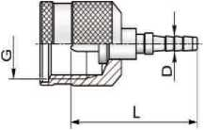
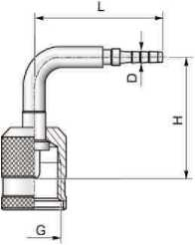
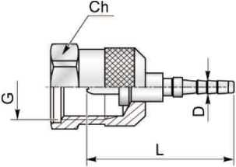
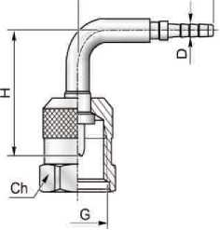

Gauges threaded fitting : P series
G | Ch | Code
M14X1.5 | 17 | P0100
M20X1.5 | 24 | P0200
G1/4〃 | 17 | P0300
G1/2” | 27 | P0400

Gauges threaded fitting : A series
Gauges threaded fitting :
W series
G | Ch | Code
M14X1.5 | 17 | P0190
M20X1.5 | 24 | P0290
G1/4〃 | 17 | P0390
G1/2〃 | 27 | P0490

G | Ch | Code
M14X1.5 | 17 | A01
M20X1.5 | 24 | A02
G1/4” | 17 | A03
G1/2” | 27 | A04

G | Ch | Code
1/4^{w} -18NPTF | 19 | W01
1/2" -14NPTF | 24 | W02

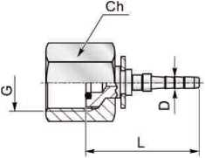
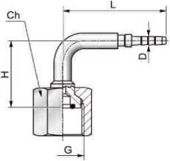
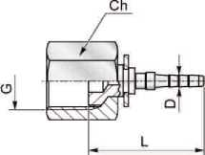
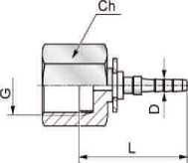

Hose End
Swivel female fitting 60° cone connection : D series
G | Ch | Code
G1/8” | 12 | D01
G1/4” | 17 | D02

Swivel female fitting 24° cone connection: Q series
G | d | Ch | Code
M08X1.0 | 4 | 10 | Q0100
M10X1.0 | 6 | 12 | Q0200
M12X1.5 | 6 | 14 | Q0300
M14X1.5 | 6 | 17 | Q0400
M14X1.5 | 8 | 17 | Q0500
M16X1.5 | 8 | 19 | Q0600
M16X1.5 | 10 | 19 | Q0700
M18X1.5 | 10 | 22 | Q0800
M18X1.5 | 12 | 22 | Q0900
M20X1.5 | 12 | 24 | Q1000

G | d | Ch | Code
M08X1.0 | 4 | 10 | Q0190
M10X1.0 | 6 | 12 | Q0290
M12X1.5 | 6 | 14 | Q0390
M14X1.5 | 6 | 17 | Q0490
M14X1.5 | 8 | 17 | Q0590
M16X1.5 | 8 | 19 | Q0690
M16X1.5 | 10 | 19 | Q0790
M18X1.5 | 10 | 22 | Q0890
M18X1.5 | 12 | 22 | Q0990
M20X1.5 | 12 | 24 | Q1090

Plug-in connection： T series
d | L | Code
3.3 | 27 | T01

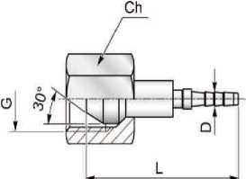
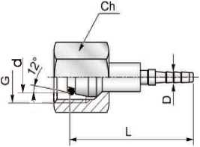
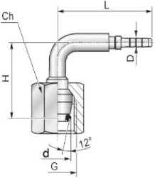
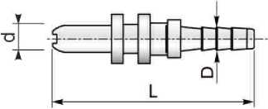

Swivel female fitting JIC 74° connection: C series
Standpipe fitting: B series
I
Banjo fitting and banjo screw： J series

G | Ch | Code
7/16-20UNF | 14 | C01
1/2-20UNF | 17 | C02
3/8-24UNF | 12 | C03
9/16-18UNF | 19 | C04

d | L | Code
4.0 | 36 | B0100
6.0 | 36 | B0200
8.0 | 37.5 | B0300

d | L | H | Code
4.0 | 33 | 25.5 | B0190
6.0 | 33 | 28.0 | B0290
8.0 | 41 | 37.0 | B0390

G | Code
M08X1.00 | J01
M10X1.00 | J02
M14X1.50 | J03
G1/4〃 | J04

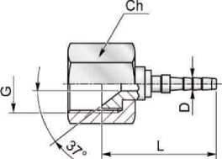
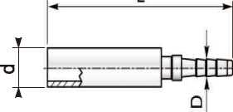
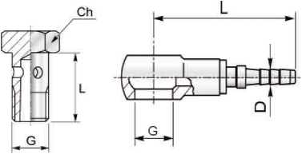

Standpipe fitting:B series
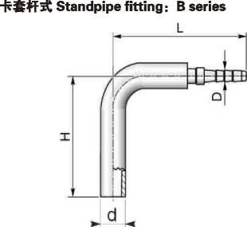

Male fittings： E series
Male fittings： Z series
Ferrule
G | Ch | Code
M8X1 | 12 | E01
M10X1 | 14 | E02
M12X1.5 | 14 | E03
M14X1.5 | 17 | E04
M16X1.5 | 19 | E05
G1/8〃 | 14 | E06
G1/4” | 17 | E07
7/16-20UNF | 12 | E08

G | Ch | Code
R1/8" -28 | 12 | Z01
R1/4^{W} -19 | 17 | Z02
1/8〃 -27NPT | 12 | Z03
1/4^{w} -18NPT | 17 | Z04

DA | DI | L | Code
8.0 | 5.5 | 15.0 | F02
9.0 | 6.5 | 15.0 | F03

Sample of test hose assembly
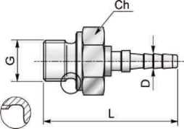
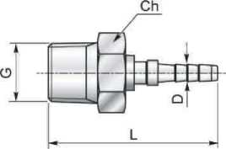
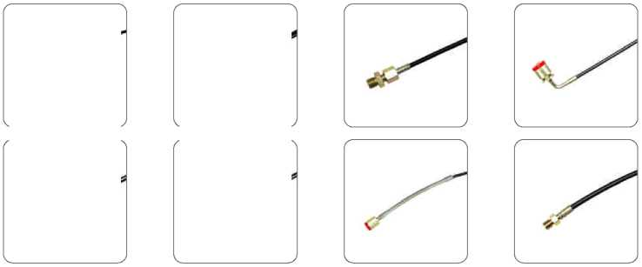
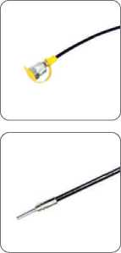
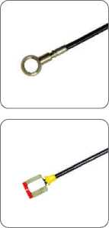

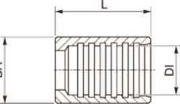

Test Coupling
PT series test couplings for pressure checking
Applications:
-Pressure control
-Lubrification
-Airbleeding
-Oil sampling
Materials:
-Galvanised carbon steel
-(Stainless steel AISI 316 is available on request)
Sealing:
-NITRILBUNAN (NBR)
-FKM-VITON (on request)
-Working temperature:
-30°C...+125°C(NITRILE BUNAN)
-25°C...+230°C(FKM)
Fluids:
-Hydraulic oils
-Mineral oils
-Suitability with otherfluids on request

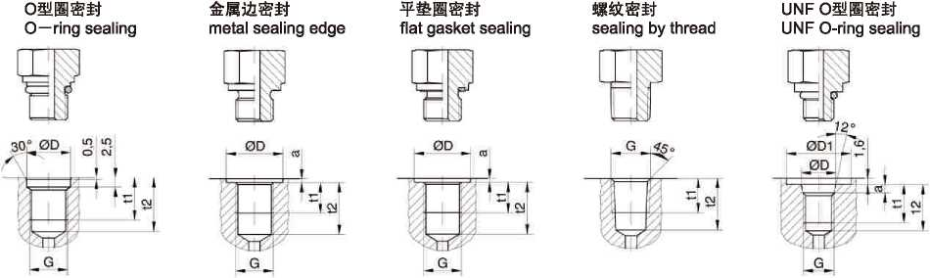

G | ΦD | t1 | t2 |  | G | ΦD | a | t1 | t2 |  | G | ΦD | a | t1 | t2 |  | G | t1 | t2 |  | G | ΦD1 | ΦD | a | t1 | t2
M08x1 | 9.5 | 11 | 15.5 |  | M08x1 | 13 | 1 | 8 | 10 |  | M10x1 | 15 | 1 | 8 | 10 |  | 1/8 NPT | 6.9 | 11.6 |  | 5/16-24 UNF | 17 | 9.1 | 1.9 | 10 | 12
M10x1 | 11.5 | 12 | 16.5 |  | M10x1 | 15 | 1 | 8 | 10 |  | M 10x1.25 | 18 | 1.5 | 10 | 15 |  | 1/4 NPT | 10 | 16.4 |  | 7/16-20 UNF | 21 | 12.4 | 2.4 | 11.5 | 14
M 10x1.25 | 11 | 12 | 16.5 |  | M 12x1.5 | 18 | 1.5 | 12 | 15 |  | M 12x1.5 | 18 | 1.5 | 12 | 15 |  | 3/8 NPT | 10.3 | 17.6 |  | 9/16-18 UNF | 25 | 15.7 | 2.5 | 12.7 | 15.5
M 14x1.5 | 15.8 | 12 | 18 |  | M 14x1.5 | 20 | 1.5 | 12 | 15 |  | M 14x1.5 | 20 | 1.5 | 12 | 15
 |  |  |  |  | M 16x1.5 | 23 | 1.5 | 12 | 15 |  | M 16x1.5 | 23 | 1.5 | 12 | 15 |  | R1/8 | 5.5 | 9.5
 |  |  |  |  | M 18x1.5 | 25 | 2 | 12 | 15 |  | M 18x1.5 | 25 | 2 | 12 | 15 |  | R1/4 | 8.5 | 13.5
 |  |  |  |  | M 20x1.5 | 27 | 2 | 14 | 17 |  | M 20x1.5 | 27 | 2 | 14 | 17 |  | R3/8 | 12 | 20
 |  |  |  |  | M 22x1.5 | 28 | 2.5 | 14 | 17 |  | M 22x1.5 | 28 | 2.5 | 14 | 17
 |  |  |  |  | M 26x1.5 | 32 | 2.5 | 16 | 19 |  | M 26x1.5 | 32 | 2.5 | 16 | 19
 |  |  |  |  | M27x2 | 33 | 2.5 | 16 | 20 |  | M27x2 | 33 | 2.5 | 16 | 20
 |  |  |  |  | M33x2 | 40 | 2.5 | 18 | 22 |  | M33x2 | 40 | 2.5 | 18 | 22
 |  |  |  |  | M42x2 | 50 | 2.5 | 20 | 24 |  | M42x2 | 50 | 2.5 | 20 | 24
 |  |  |  |  | M48x2 | 56 | 2.5 | 22 | 26 |  | M48x2 | 56 | 2.5 | 22 | 26
 |  |  |  |  | G 1/8 | 15 | 1 | 8 | 10.5 |  | G1/8 | 15 | 1 | 8 | 10.5
 |  |  |  |  | G1/4 | 20 | 1.5 | 12 | 15.5 |  | G 1/4 | 20 | 1.5 | 12 | 15.5
 |  |  |  |  | G3/8 | 23 | 2 | 12 | 15.5 |  | G3/8 | 23 | 2 | 12 | 15.5
 |  |  |  |  | G1/2 | 28 | 2.5 | 14 | 18.5 |  | G1/2 | 28 | 2.5 | 14 | 18.5
 |  |  |  |  | G3/4 | 33 | 2.5 | 16 | 20 |  | G3/4 | 33 | 2.5 | 16 | 20
 |  |  |  |  | G1 | 40 | 2.5 | 18 | 23 |  | G1 | 40 | 2.5 | 18 | 23
 |  |  |  |  | G11/4 | 50 | 2.5 | 20 | 25 |  | G11/4 | 50 | 2.5 | 20 | 25
 |  |  |  |  | G 1 1/2 | 56 | 2.5 | 22 | 27 |  | G 11/2 | 56 | 2.5 | 22 | 27

Test Coupling
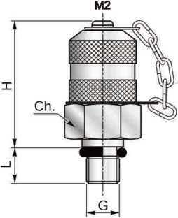
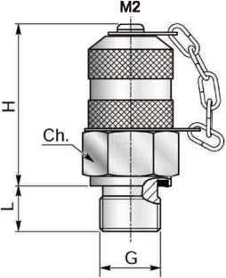
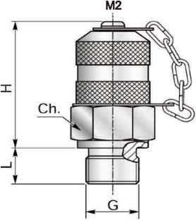

Code | G | M2 | Ch | L | H | Choice sealing type
PT-01 | M08X1.00 | M16X2 | 17 | 8.0 | 37.0 | A、B、C
PT-02 | M10X1.00 | M16X2 | 17 | 8.0 | 37.0 | A、B、C
PT-03 | M12X1.50 | M16X2 | 17 | 10.0 | 37.0 | A、B、C
PT-04 | MMX 1.50 | M16X2 | 19 | 12.0 | 37.0 | A、B、C
PT-05 | M16X1.50 | M16X2 | 22 | 12.0 | 37.0 | A、B、C
PT-06 | G1/8” | M16X2 | 17 | 10.0 | 37.0 | A、B、C
PT-07 | G1/4^{Z,} | M16X2 | 19 | 12.0 | 37.0 | A、B、C
PT-08 | G3J8” | M16X2 | 22 | 14.0 | 37.0 | A、B、C
PT-09 | G1/2^{W} | M16X2 | 27 | 15.0 | 37.0 | A、B、C
PT-10 | 7716" -20UNF | M16X2 | 17 | 10.0 | 37.0 | E
PT-11 | 1/2^{w} -20UNF | M16X2 | 17 | 10.0 | 37.0 | E
PT-12 | 9/16^{W} -18UNF | M16X2 | 19 | 10.0 | 37.0 | E
If you need test coupling with exhaust,the code will be PPT-W,such as PPT-01.

Code | G | M2 | Ch | L | H | Choice sealing type
PT-15 | R1/8” | M16X2 | 17 | 10.0 | 37.0 | D
PT-16 | R1/4” | M16X2 | 19 | 12.0 | 37.0 | D
PT-17 | R3/8“ | M16X2 | 22 | 14.0 | 37.0 | D
PT-18 | 1/8" -27NPTF | M16X2 | 17 | 10.0 | 37.0 | D
PT-19 | 1/4" -18NPTF | M16X2 | 19 | 14.0 | 37.0 | D
PT-20 | 318" -18NPTF | M16X2 | 22 | 16.0 | 37.0 | D

Test Coupling
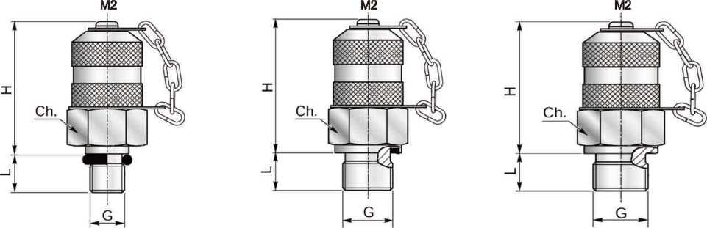

Code | G | M2 | Ch | L | H | Choice sealing type
PT-13 | M10X1 | M12X1.25 | 17 | 8.0 | 37.0 | A、B、C

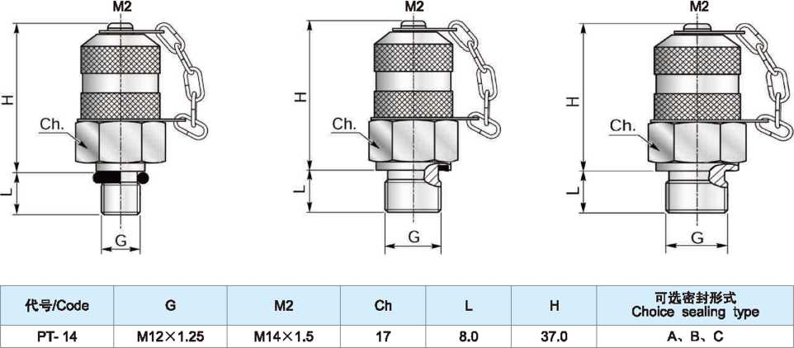
M2
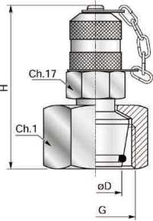

Code | G | 0D | M2 | Ch.1 | H | Choice sealing type
PTQ-01 | M12X1.50 | 06L | M16X2 | 14 | 54.0
PTQ-02 | M14X1.50 | 06S | M16X2 | 17 | 54.0
PTQ-03 | M14X1.50 | 08L | M16X2 | 17 | 54.0
PTQ-04 | M16X1.50 | 08S | M16X2 | 19 | 59.0
PTQ-05 | M16X1.50 | 10L | M16X2 | 19 | 59.0
PTQ-06 | M18X1.50 | 10S | M16X2 | 22 | 59.0
PTQ-07 | M18X1.50 | 12L | M16X2 | 22 | 59.0
PTQ-08 | M20X1.50 | 12S | M16X2 | 24 | 59.0
PTQ-09 | M22X1.50 | 14S | M16X2 | 27 | 59.0
PTQ-10 | M22X1.50 | 15L | M16X2 | 27 | 59.0
PTQ-11 | M24X1.50 | 16S | M16X2 | 30 | 59.0
PTQ-12 | M26X1.50 | 18L | M16X2 | 32 | 59.0
PTQ-13 | M30X2.00 | 20S | M16X2 | 36 | 59.0
PTQ-14 | M30X2.00 | 22L | M16X2 | 36 | 62.0
PTQ-15 | M36X2.00 | 28L | M16X2 | 41 | 60.0
PTQ-16 | M36X2.00 | 25S | M16X2 | 46 | 65.0
PTQ-17 | M42X2.00 | 30S | M16X2 | 50 | 65.0
PTQ-18 | M45X2.00 | 35L | M16X2 | 50 | 62.0
PTQ-19 | M52X2.00 | 38S | M16X2 | 60 | 65.0
PTQ-20 | M52X2.00 | 42L | M16X2 | 60 | 65.0
If you need test coupling with exhaust,the code will be PPTQ-*,such as PPTQ-01.
M2
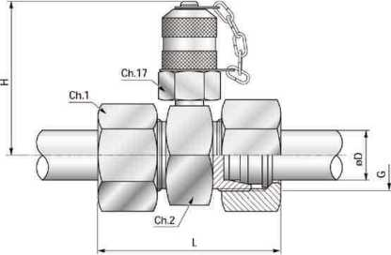

Code | G | 0D | M2 | Ch.1 | H | Choice sealing type
PTT-01 | M12X1.50 | 06L | M16X2 | 14 | 54.0
PTT-02 | MMX 1.50 | 06S | M16X2 | 17 | 54.0
PTT-03 | MUX 1.50 | 08L | M16X2 | 17 | 54.0
PTT-04 | M16X1.50 | Q8S | M16X2 | 19 | 59.0
PTT-05 | M16X1.50 | 10L | M16X2 | 19 | 59.0
PTT-06 | M18X1.50 | 10S | M16X2 | 22 | 59.0
PTT-07 | M18X1.50 | 12L | M16X2 | 22 | 59.0
PTT-08 | M20X1.50 | 12S | M16X2 | 24 | 59.0
PTT-09 | M22X1.50 | 14S | M16X2 | 27 | 59.0
PTT-10 | M22X1.50 | 15L | M16X2 | 27 | 59.0
PTM1 | M24X1.50 | 16S | M16X2 | 30 | 59.0
PTT-12 | M26X1.50 | 18L | M16X2 | 32 | 59.0
PTT-13 | M30X2.00 | 20S | M16X2 | 36 | 59.0
PTT-14 | M30X2.00 | 22L | M16X2 | 36 | 62.0
PTT-15 | M36X2.00 | 28L | M16X2 | 41 | 60.0
PTT-16 | M36X2.00 | 25S | M16X2 | 46 | 65.0
PTT-17 | M42X2.00 | 30S | M16X2 | 50 | 65.0
PTT-18 | M45X2.00 | 35L | M16X2 | 50 | 62.0
PTT-19 | M52X2.00 | 38S | M16X2 | 60 | 65.0
PTT-20 | M52X2.00 | 42L | M16X2 | 60 | 65.0

M2
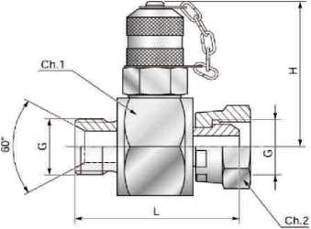

Code | G | M2 | Ch.1 | Ch.2 | H | choice sealing type
PTD-01 | G1/4" | M16X2 | 32 | 19 | 54.0
PTD-02 | G3/8” | M16X2 | 32 | 22 | 54.0
PTD-03 | G1/2" | M16X2 | 32 | 27 | 54.0
PTD-04 | G3/4” | M16X2 | 32 | 32 | 59.0
PTD-05 | G1" | M16X2 | 41 | 41 | 59.0

M2
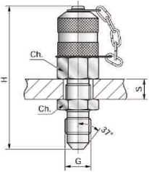

Code | G | M2 | Ch | S max | H | Choice sealing type
PTG-01 | 7/16^{H}-20UNF | M16X2 | 32 | 9 | 68.0
PTG-02 | 1/2^{H}-20UNF | M16X2 | 32 | 9 | 68.0
PTG-03 | 9/16^{H}-18UNF | M16X2 | 32 | 9 | 69.0

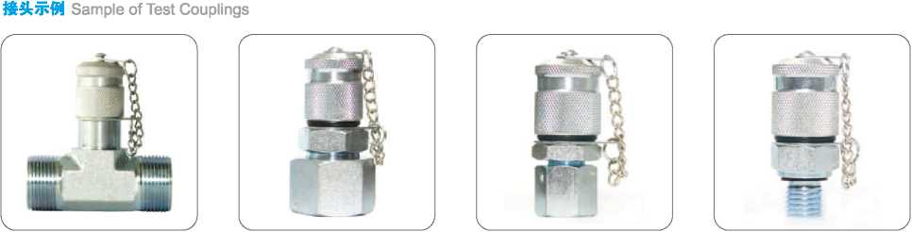

测压盒
Pressure Test Kit
测压盒 Pressure Test Kit
型号(Type): GDTK-25
配置描述Description | 数量Quantity： PCS
压力表 Pressure gauge:(t>63mm ~ 6MPa | 1
压力表 Pressure gauge: cb63mm ~ 25MPa | 1
测压软管 Test hose: Length = 1500mm | 2
微型测压头 Test coupling: G1/4, | 1
微型测压头 Test coupling: M14x 1.5 | 1

型号(Type)： GDTK-40
(Type)： GDTK-60
配置描述Description | 数量Quantity： PCS
压力表 Pressure gauge:中63mm~ 10MPa | 1
压力表 Pressure gauge:(t)63mm~25MPa | 1
压力表 Pressure gauge: 463mm ~ 40MPa | 1
测压软管 Test hose: Length = 1500mm | 3
微型测压头 Test coupling: M10*1, | 1
微型测压头 Test coupling: M14x 1.5 | 1
微型测压头 Test coupling: G1/4, | 1
微型测压头 Test coupling: R1/4 | 1

配置描述Description | 数量Quantity： PCS
压力表Pressure gauge: c|)63mm ~ 25MPa | 1
压力表Pressure gauge: 4)63mm ~40MPa | 1
压力表Pressure gauge: 063mm ~ 60MPa | 1
测压软管Test hose: Length = 1500mm | 3
微型测压头Test coupling: M10*1, | 1
微型测压头Test coupling: M14x 1.5 | 1
微型测压头Test coupling: G1/4, | 1
微型测压头Test coupling: R1/4 | 1
微型测压头Test coupling: UNF7/16-20 | 1
微型测压头Test coupling: NPT1/4-18 | 1

Remark： Pressure gauge and test couplings can be changed according to custome
